Sample for PE  
SUMMER 2021  
Subject: WED201c  
Duration: 120 minutes

**Objectives:**

1. Create the css files and link it to the html files.
2. Create a file named yourCode.js and link it to the html files.
3. Use html tags to create a web page.

**Background:**

In this practice exam, you are given a folder “**Resource**”. You are going to use page “index.html” to finish the exam.

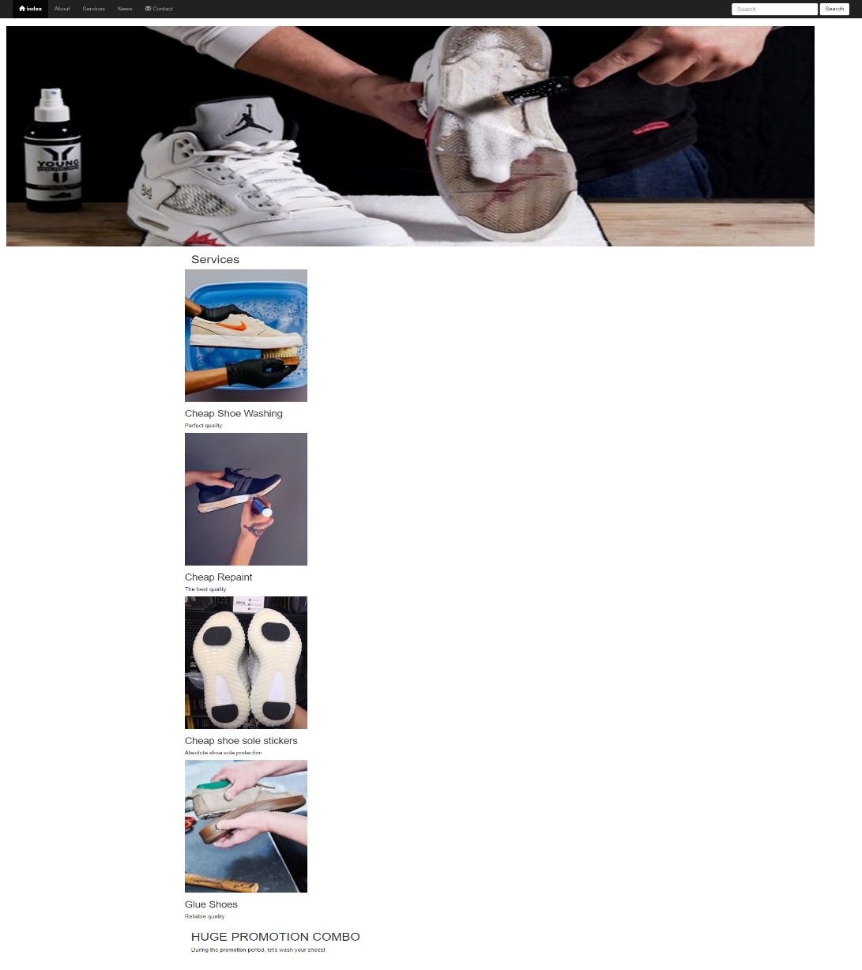**Before styling index.html page**

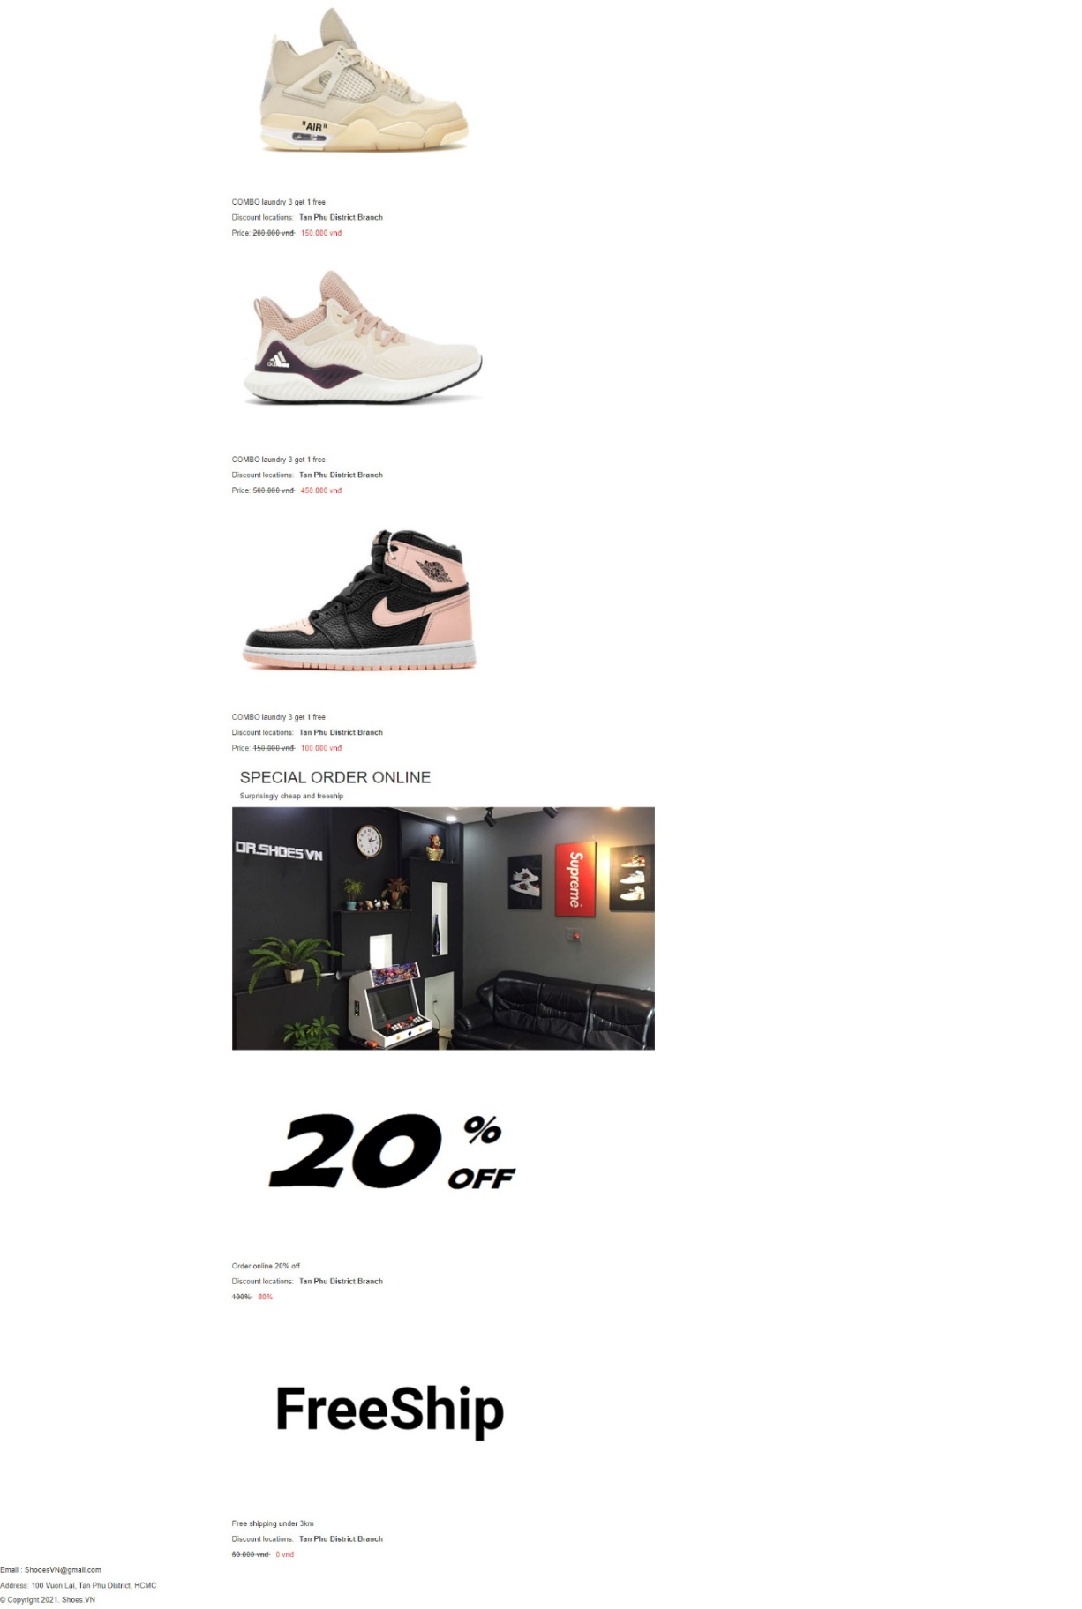

**After styling index.html page**



**The index.html page structure when users access by smartphone**

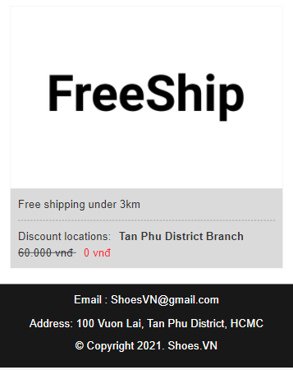****

**Required:**

1. Create a file with the name **contact.html** and save it to **Resourse folder** as shown below:

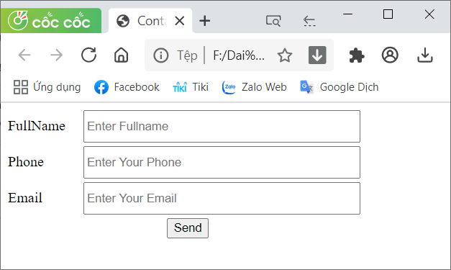

1. Create a file called **styleindex.css** to format the index.html page and save it to the **Resource folder**.
2. Create a file called **stylecontact.css** to format the contact.html page and save it to the **Resource folder**.
3. Create a file called “**mycode.js**” and save it to the **Resource folder.** You must link this file to the contact.html page.

**Evaluation**

1. **Add html tags [4 marks]**

* Use Bootstrap's 12-column grid to present the content of the index.html page [1 points].
* Use tags div, label, input to create contact.html [1.5 points].
* Create a link for the contact menu to open the contact.html page [0.5 points].
* Embed css and js files in their respective pages [1 points].

1. **CSS [ 5 marks]**

* Create classes for the divs to format the content of the index.html page[2 points].
* Use margin and padding to create the right spacing for the content [1 points].
* Use position,width, height to format the content [1 points].
* Use css to format the content as shown above when the user accesses by smartphone [1 points].

1. **Javascript [1 marks]**

* In mycode.js file, you must **create function** base on description:
* The function show(): This function is used to show message when the user clicks on the button “Send”.

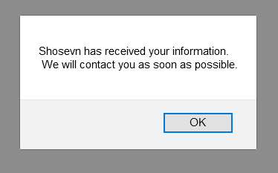

**Total: 10 points  
 (Students do not change the path of all files in the Resource folder)**

--The End--